**Question 1 : Problem Statement**

Implement a class Calculator with the method mentioned below.

**Method Description**

**findAverage()**

* Calculate the average of three numbers
* Return the average rounded off to two decimal digits

Test the functionalities using the provided Tester class.

**Sample Input and Output**

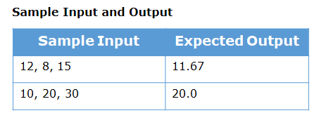

**Question 2 : Problem Statement**

Implement the class Teacher based on the class diagram and description given below.

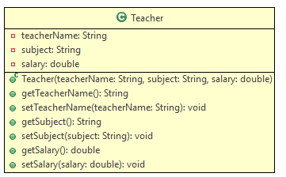

**Method Description**

Teacher(String teacherName, String subject, double salary)

Initialize the values of all the instance variables appropriately with the values passed

Create a Tester class. Create 4 objects of Teacher class. Create an array of type Teacher store the created objects and display the details of the teachers.

**Sample Input and Output**

**Input**

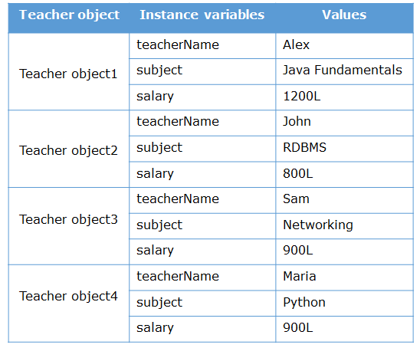

**Output**

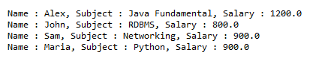

**Question 3 : Design GUI form as given**